**BINARY TO DECIMAL CONVERSION**

**EXP NO: 24**

**AIM:** To write a C program to implement binary to decimal conversion.

**ALGORITHM:**

1. Start
2. Read the binary number from the user, say ‘n’
3. Initialize the decimal number, d=0
4. Initialize i=0

|  |  |
| --- | --- |
| 5) Repeat while n != 0: |  |
| i. | Extract the last digit by: remainder = n % 10 |
| ii. | n = n/10 |
| iii. | d = d + (remainder * 2<sup>i</sup>) |
| iv. | Increment i by 1 |

1. Display the decimal number, d
2. Stop

**PROGRAM:**

#include <stdio.h> void main()

{

int num, binary_num, decimal_num = 0, base = 1, rem; printf (" Enter a binary number with the combination of 0s and 1s \n"); scanf (" %d", &num); binary_num = num; while ( num > 0)

{

rem = num % 10;

decimal_num = decimal_num + rem * base; num = num / 10; base = base * 2;

}

printf ( " The binary number is %d \t", binary_num); printf (" \n The decimal number is %d \t", decimal_num);

}

**INPUT:**

**1111**

**OUTPUT:**

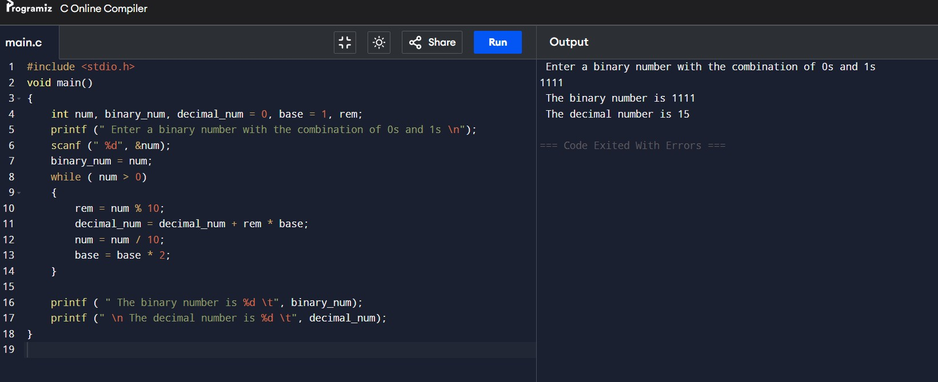

**RESULT:** Thus the program was executed successfully using DevC++.